Q1. What is this button called? | 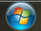
- Start

Q2. What is the difference between left-mouse-click and right-mouse-click?
- Left- To perform an action.
Right- To offers more options.

Q3. What happens when you press CTRL and ALT and DEL together at the same time?
- To switch user, log off, change a password, or start the task manager.

 | A B C D E
Q4. What do these cursors mean? | 
- Pointing
- Pointing
- Typing
- Loading
- Unable
Q5. Label the diagram given below:
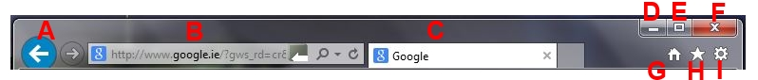
A - Back
B - URL
C - Google search
D - Minimize
E - Maximize
F - Close
G – Home page
H - Bookmark
I - Settings

